**Experiment No. 4**

**SAP Id: 500083382**

**Batch: B5-H**

**Name of the Student: Anurag Singh**

**Task:** Design a program for error detection using C program

**Code:**

#include <stdio.h>

int main()

{

    // design a program for error detection using c program

    int data[10]={1,0,1,1,0,1};

    int noise[10]={0,0,0,0,0,1};

    int result[10];

    // binary addition of data and noise

   int carry=0;

    for( int i = 0; i < 6; i++ )

    {

        int bitA = i < 6 && data[i] ? 1 : 0;

        int bitB = i < 6 && noise[i] ? 1 : 0;

        int sum = bitA + bitB + carry;

        result[i] = sum == 1 || sum == 3 ? 1 : 0;

        carry = sum > 1 ? 1 : 0;

    }

     result[ 6 ] = carry;

     printf("\n result:");

     for(int i=0;i<6;i++)

     {

         printf("%d",result[6-i]);

     }

     for(int i=0;i<6;i++){

         if(result[i]!=data[i]){

             printf("\nError detected at bit %d",i);

             break;

         }

     }

    return 0;

}

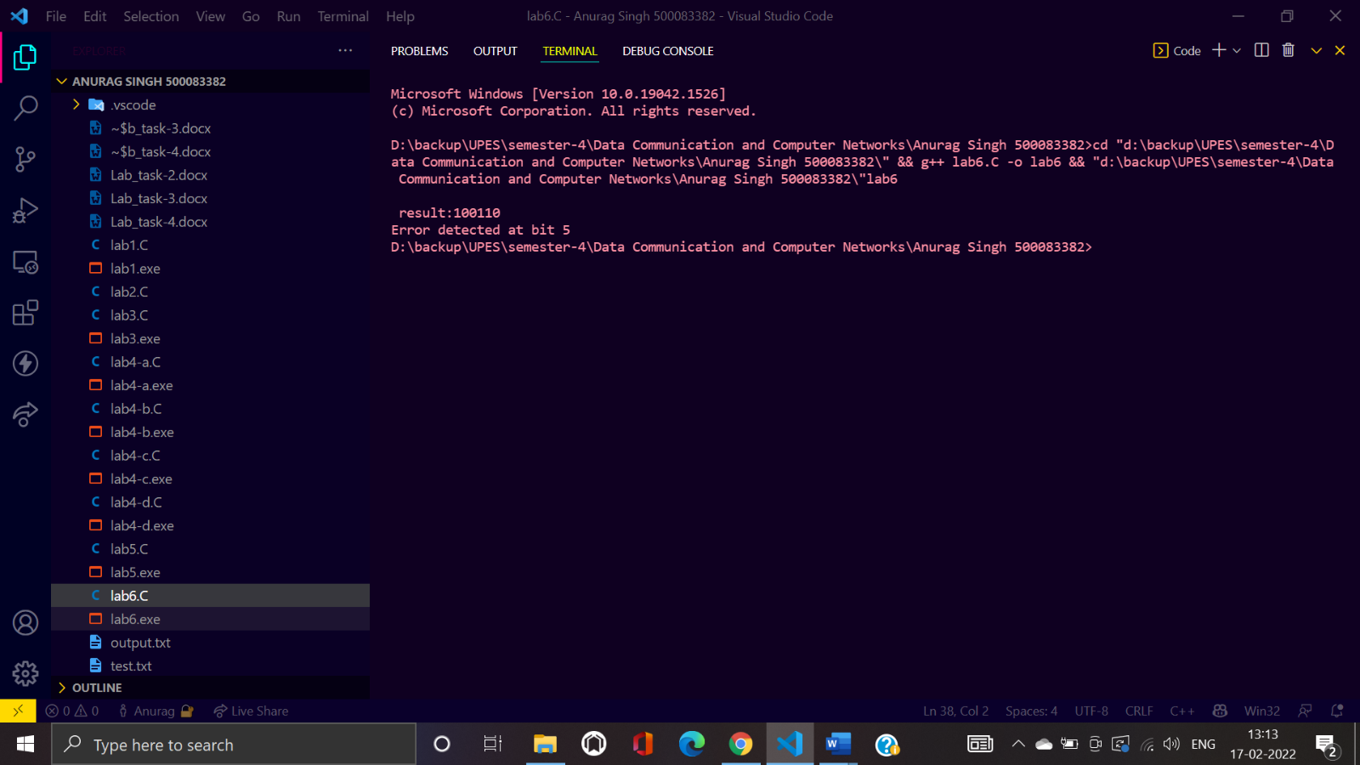**Screenshot:**